CD LAB 1

Name: Rhea Adhikari
Reg No: 190905156
Roll No: 23

1. To count the number of lines and characters in a file.

#include <stdio.h>
#include <stdlib.h>

int main()
{
FILE *fptr1, *fptr2;

char filename[100], c;

printf("Enter the filename to open for reading: \n");
scanf("%s", filename);

fptr1 = fopen(filename, "r");

// Open one file for reading
if (fptr1 == NULL)
{
printf("Cannot open file %s \n", filename);
exit(0);
}

c = fgetc(fptr1);
// printf("%c\n",c);

int lines=1,characters=1;

// Read contents from file
while (c != EOF)
{
c = fgetc(fptr1);
// printf("%c\n",c);

if(c=='\n'){
lines++;
}

if(c!=EOF && c!='\n')
characters++;

}

printf("\nTotal no.of lines= %d and characters= %d.\n", lines,characters);
fclose(fptr1);

return 0;
}

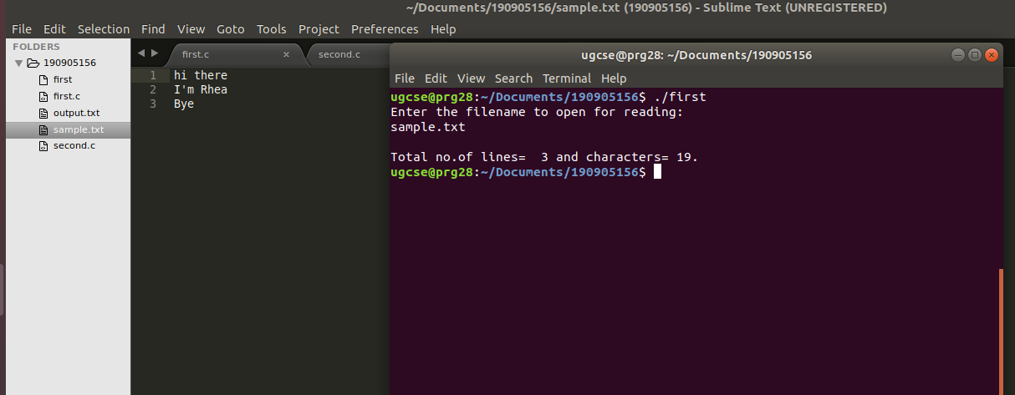
2. To reverse the file contents and store in another file. Also display the size of file
using file handling function.

#include <stdio.h>
#include <stdlib.h>

int main()
{
FILE *fptr1, *fptr2;

char filename[100], c;

printf("Enter the filename to open for reading: \n");
scanf("%s", filename);
fptr1 = fopen(filename, "r");

// Open one file for reading
if (fptr1 == NULL)
{
printf("Cannot open file %s \n", filename);
exit(0);
}

printf("Enter the filename to open for writing: \n");
scanf("%s", filename);
fptr2 = fopen(filename, "w+"); // Open another file for writing

//Store in arr
char arr[100];
int i=0;

c = fgetc(fptr1);

// Read contents from file
while (c != EOF)
{
arr[i++]=c;
c = fgetc(fptr1);
}

for(int j=i-1;j>=0;j--){
c=arr[j];
fputc(c,fptr2);
}

printf("\nContents copied to %s in reverse order\n", filename);

long int res = ftell(fptr1);

printf("Size of the file is %ld bytes \n", res);

fclose(fptr1);
fclose(fptr2);

return 0;
}

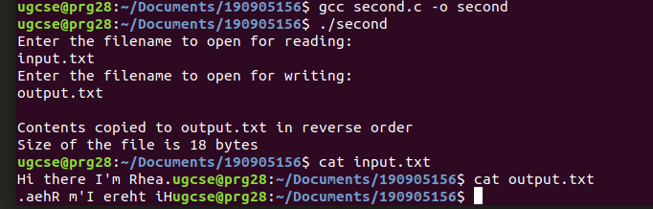
3. That merges lines alternatively from 2 files and stores it in a resultant file.

#include <stdio.h>
#include <stdlib.h>

int main(){

FILE *fptr1,*fptr2,*res;

char c,c1,c2;
char filename[100];

printf("Enter the first filename to open for reading: \n");
scanf("%s", filename);
fptr1 = fopen(filename, "r");

// Open one file for reading
if (fptr1 == NULL)
{
printf("Cannot open file %s \n", filename);
exit(0);
}

printf("Enter the second filename to open for reading \n");
scanf("%s", filename);
fptr2 = fopen(filename, "r");

// Open one file for reading
if (fptr2 == NULL)
{
printf("Cannot open file %s \n", filename);
exit(0);
}

printf("Enter the filename to open for writing: \n");
scanf("%s", filename);
res = fopen(filename, "w+"); // Open another file for writing

c1=fgetc(fptr1);
c2=fgetc(fptr2);

int toggle=0;

while(c1!=EOF && c2!=EOF){
if(toggle==0){
c=c1;
c1=fgetc(fptr1);
if(c1=='\n'){
toggle=1;
}
}
else{
c=c2;
c2=fgetc(fptr2);
if(c2=='\n'){
toggle=0;
}
}
fputc(c,res);
}

while(c1!=EOF){
fputc(c1,res);
c1=fgetc(fptr1);
}
while(c2!=EOF){
fputc(c2,res);
c2=fgetc(fptr2);
}

return 0;

}

